**Varnali Gandhi**

**My Python project**

**Used following URL API’S:**

<https://www.inferentialthinking.com/data/little_women.txt>

[http://archive.ics.uci.edu/ml/machine-learning-databases/iris/.](http://archive.ics.uci.edu/ml/machine-learning-databases/iris/)

<http://archive.ics.uci.edu/ml/machine-learning-databases/breast-cancer-wisconsin/>

Contents

Task-1 3

Action-1 5

output: 5

Action-2 7

Output: 8

Action-3 9

9

Output: 9

Action-4 9

Output: 10

Scatter daigram: 11

Action-5: 12

Task-2 12

Action-1: 13

Action-2: 13

output: 13

Action-3: 13

output: 14

Action-4: 14

Action-5: 14

Action-6: 14

Output: 14

Action-7: 15

output: 15

Action-8: 15

output: 16

Action-10: 16

output: 16

Task-3 16

Action-1: 16

Action-2 16

Action-3 17

output: 17

Action-4: 17

output: 18

Task-4: 18

Action-1 18

Action-2 18

Action-3 19

output: 19

Action:5 19

Action-6: 20

output: 20

# Task-1

task-1 is about data visualization and Analytics . Data visualization is used to represents graphical fundamentals of data and information. It allows user to understand [analytics](https://www.sas.com/en_nz/insights/analytics/what-is-analytics.html) presented visually,so they can hold difficult concepts or categorize innovative patterns. With interactive visualization, user can take the concept a step further by using technology to drill down into charts and graphs to perform different actions first need to read whole text of the novel than it will become easy to perform different actions.

* **from urllib.request import urlopen**= It is one of the python module for fetching the URLs it endeavor a very transparent interface in the configuration of urlopen function
* **import pandas as pd**= It is used to adapt python’s list, dictionary or num py array in to pandas data frame
* **from matplotlib import pyplot as plot**= It is the assemblage of command style functions each of the pyplot is a function which makes some variations to a figure.it put some lines in a plotting range, it generates a figure

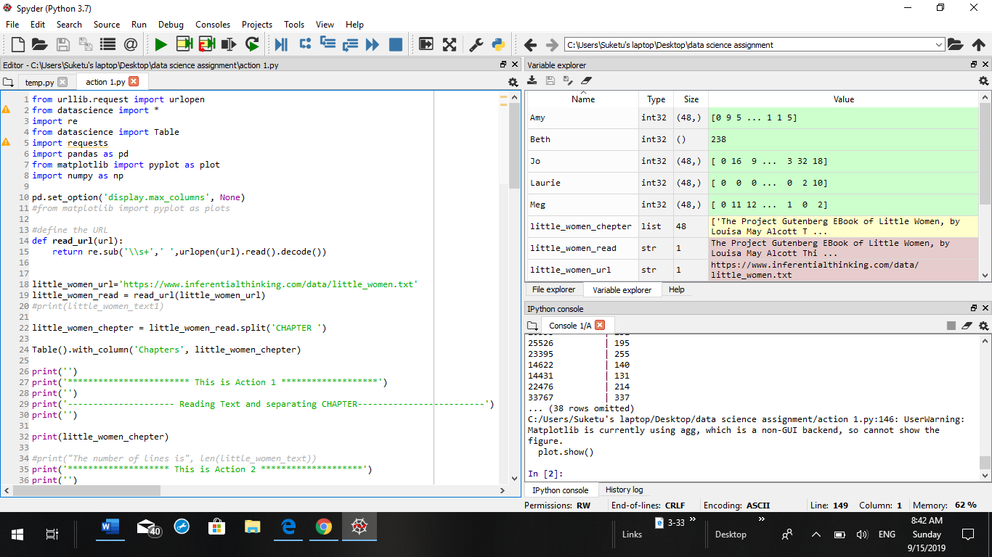

After implementing to read the text from the novel the result came this as mentioned below:

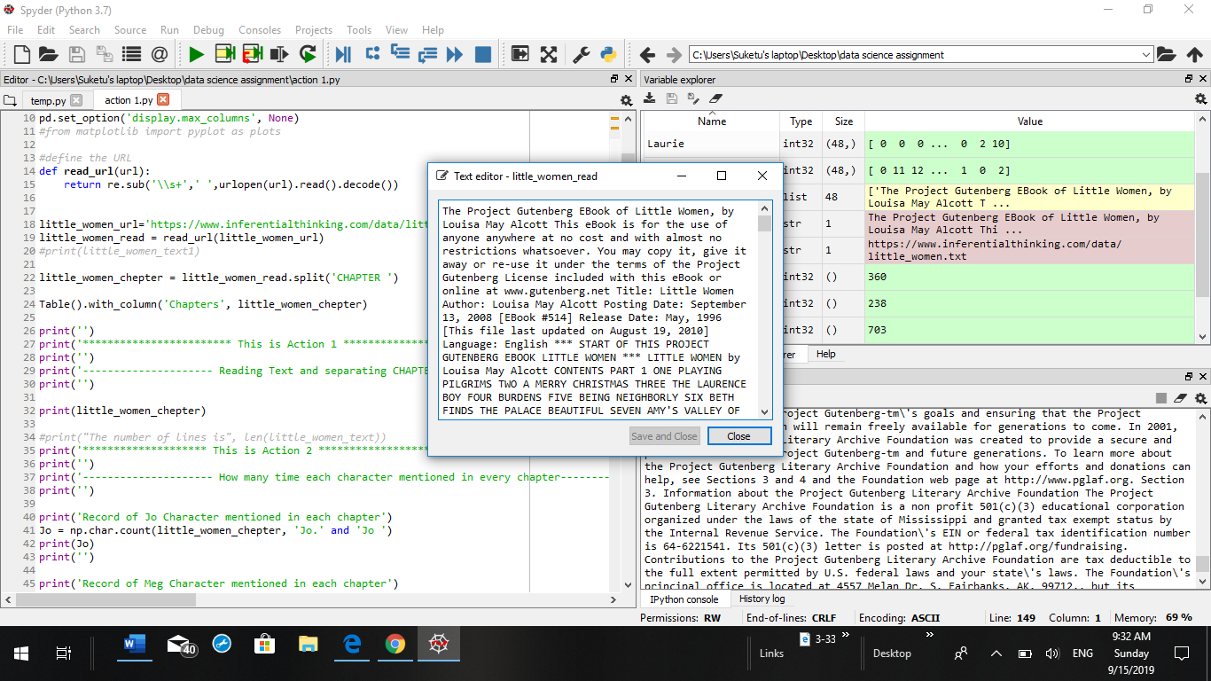

## Action-1

In Action1 we need to separate chapters from the novel little_women_url

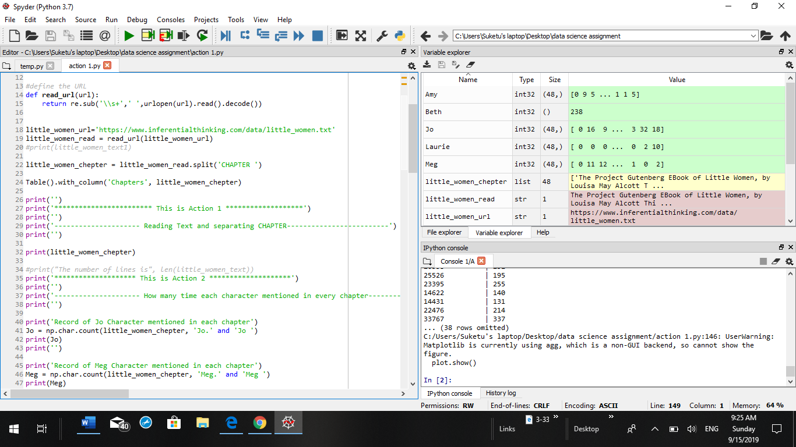

After the first action got implemented chapter wise whole text was showed in table

**Table().with_column**= It creates the table including columns and rows for fetching the data of the novel

### output:

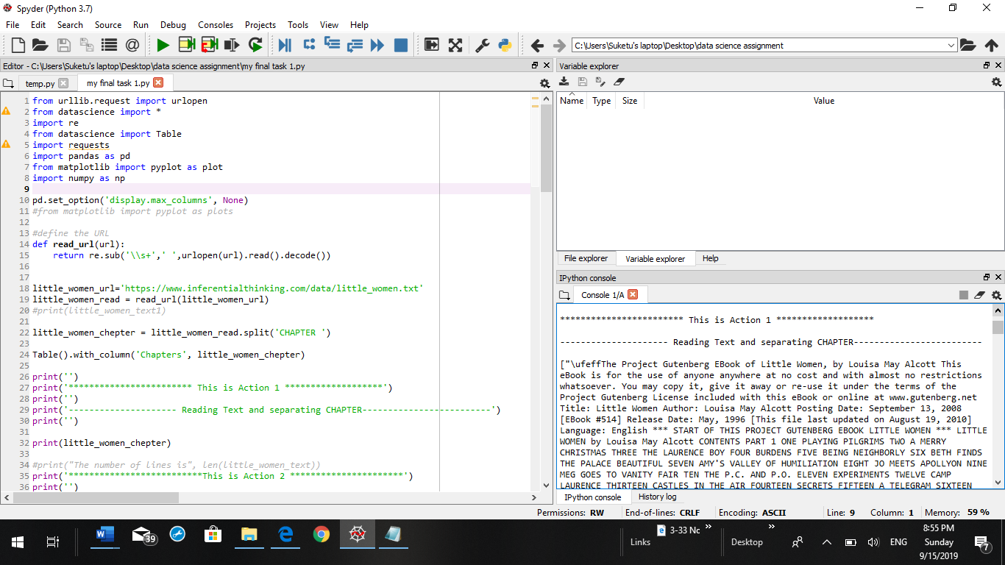

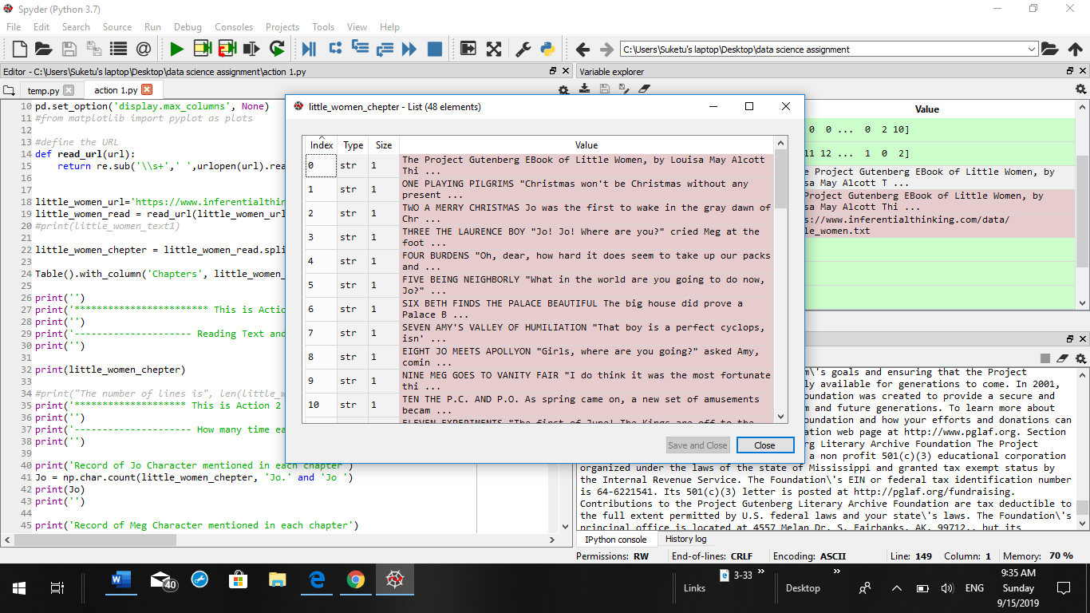

on clicking on index 5 it will show the chapter five so if user click on different index it will show different chapters including it text

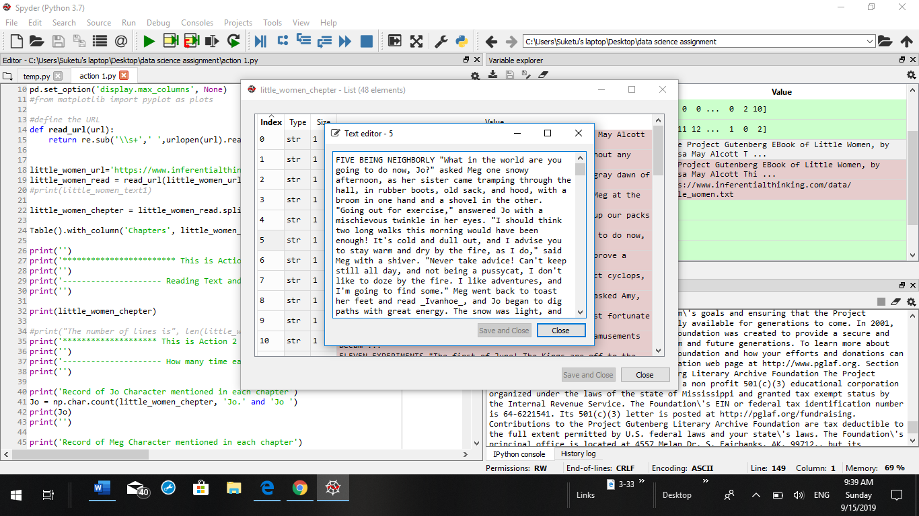

## Action-2

in Action-2 it was articulate that each of the character mentioned how much of time in each and every chapter by this technique user can examine the characters in novel and user can also know which character is main character in the whole novel. It calculate all the character in the based on novel

**np.char.count =** this function will accomplish number of non-extending occurrences that will return an array with the accordance of substring in the range. This function is use to count the each character from the novel

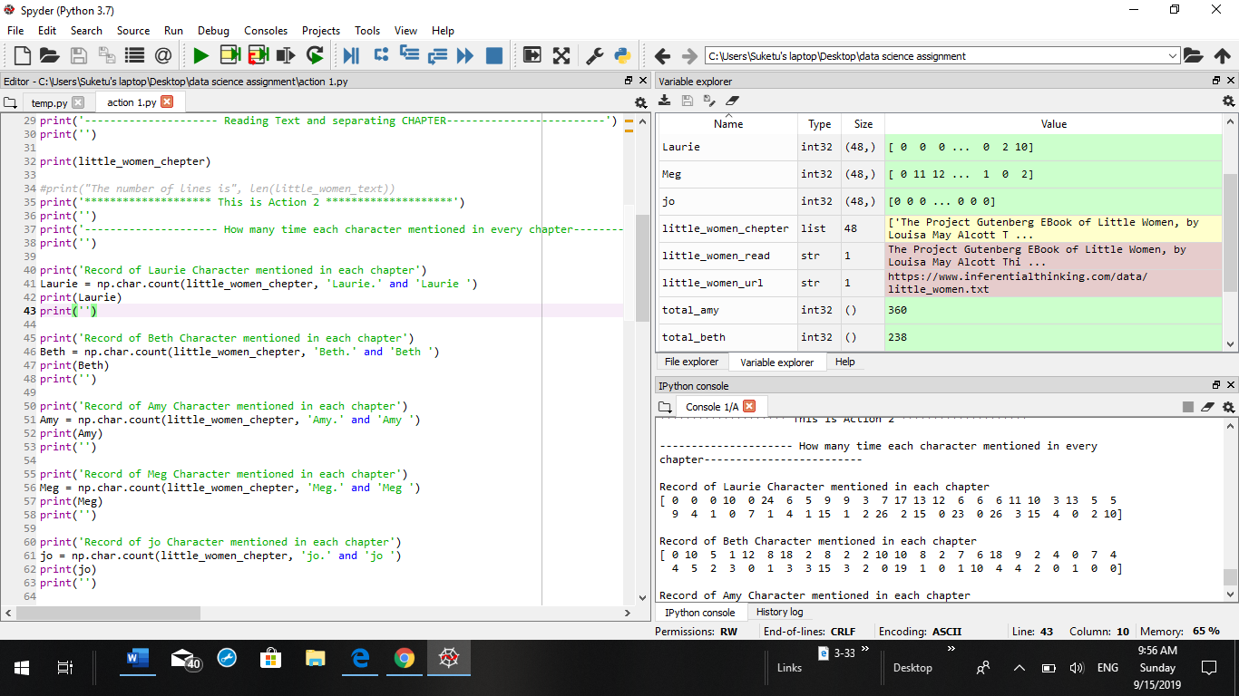

### Output:

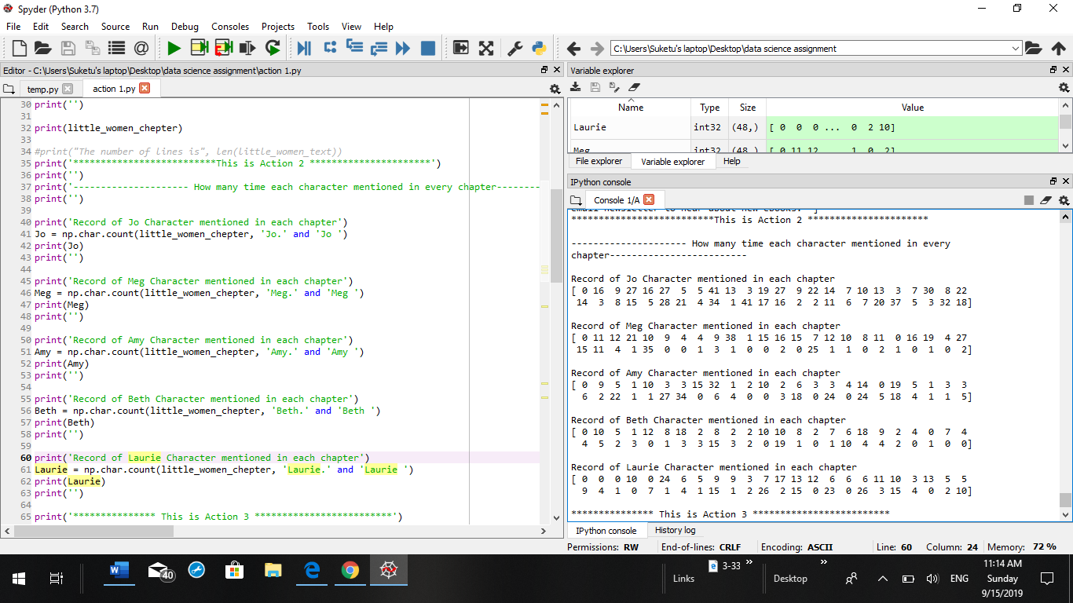

from the output it is observed that JO character mentioned in each chapter is for maximum time and other four characters Meg, Amy , Beth, Laurie were played less role in whole novel

## Action-3

In Action-3 the data science library convert the number of character into the table

**count=Table().with_columns**=This function is use to create the table to show characters in systematic way and it is easy to read the calculated number of character from the table

### 

### Output:

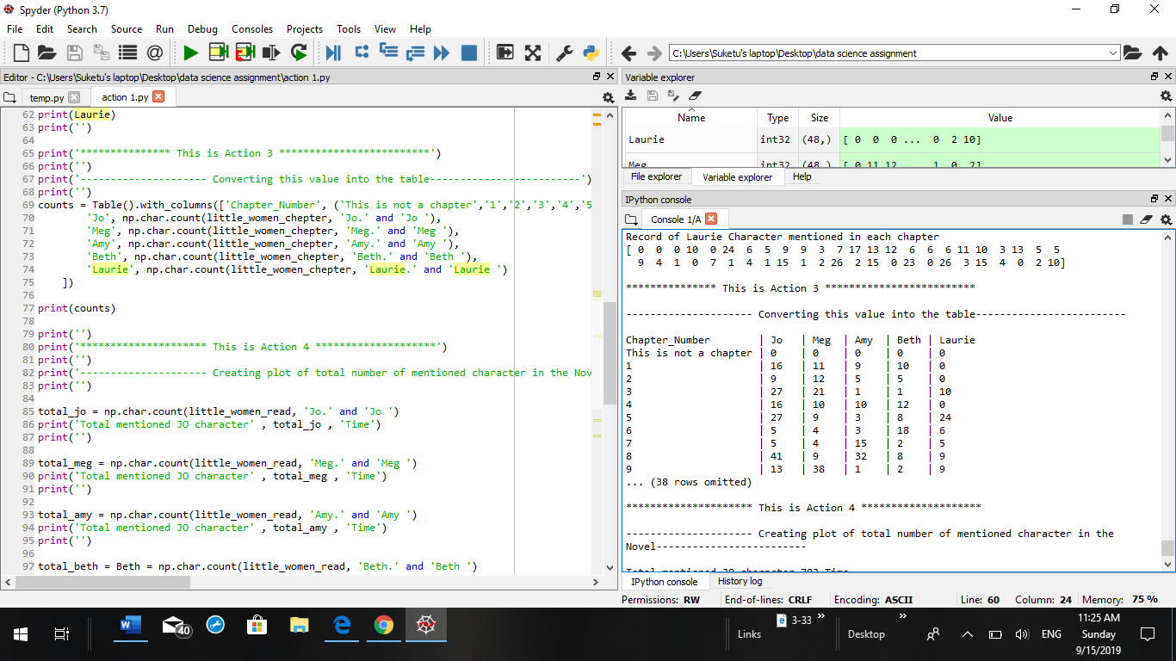

from the above table it was observe that Jo character appeared maximum times in the novel compared to other characters in the novel . Number and character are appeared systematically in each rows and columns.

## Action-4

In Action 4 within the span of each chapter artifice a scatter diagram by applying Table construct. By keeping some points like stipulations of total character as chapter-wise also in terms of sum of all the sentences in the chapter. As per the Action 4 each character has been calculated each of the time in the chapters that all represent in output in the form of table.

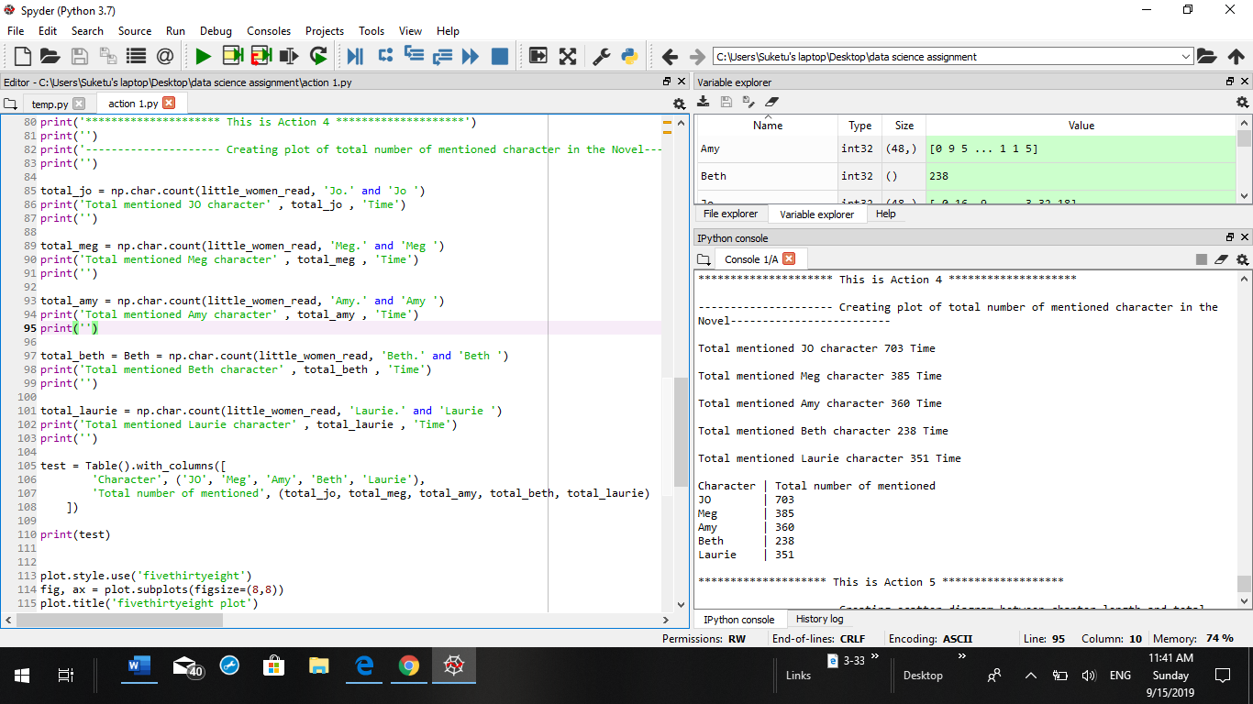

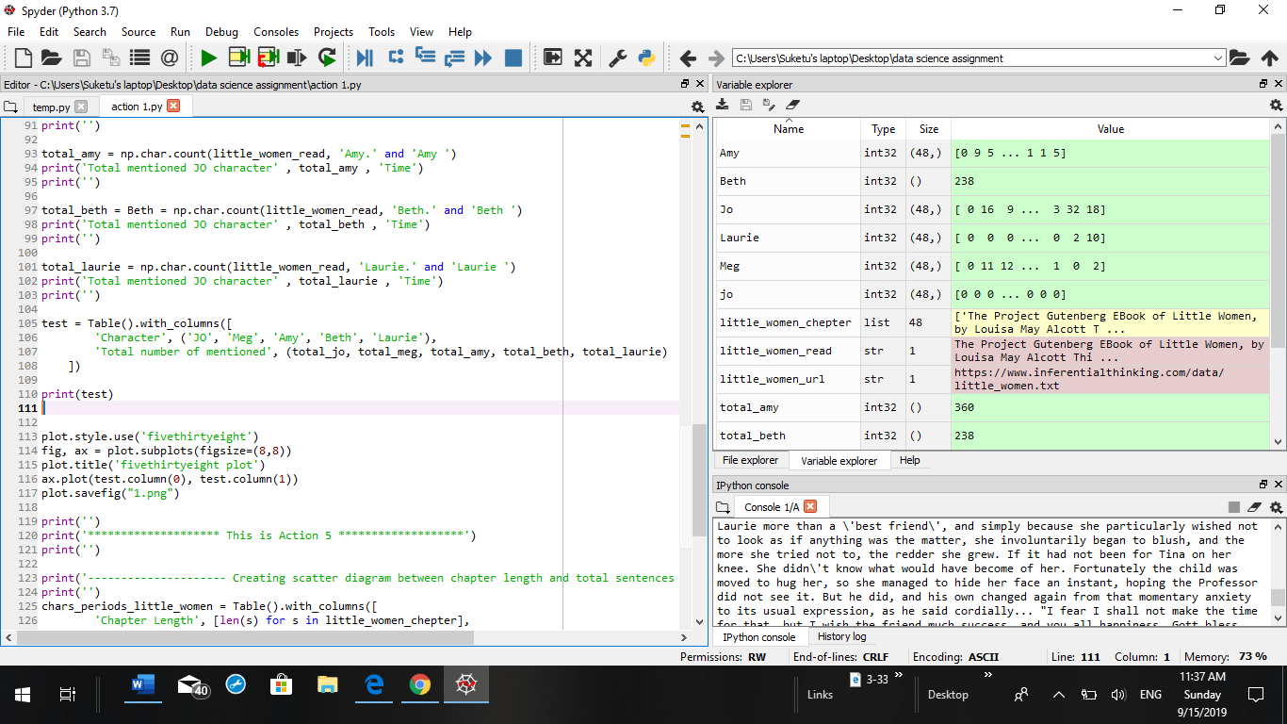

### Output:

As it was observed in the output total number of characters stated in the novel by constructing the plot for how many times the character was mentioned. So, we can see that first character “Jo” was specified 703 times which is the most maximum number of times mentioned in the whole novel, by observing at second character whose name is “Meg” was specified 385 numbers of time in total mentioned in chapters. “Amy” which was the third character was specified 360 times in the chapters, “Laurie” which is the fourth maximum mentioned character in the novel which was 351 time, last but not the least “Beth” which was mentioned very less time in the novel which was 238 times.

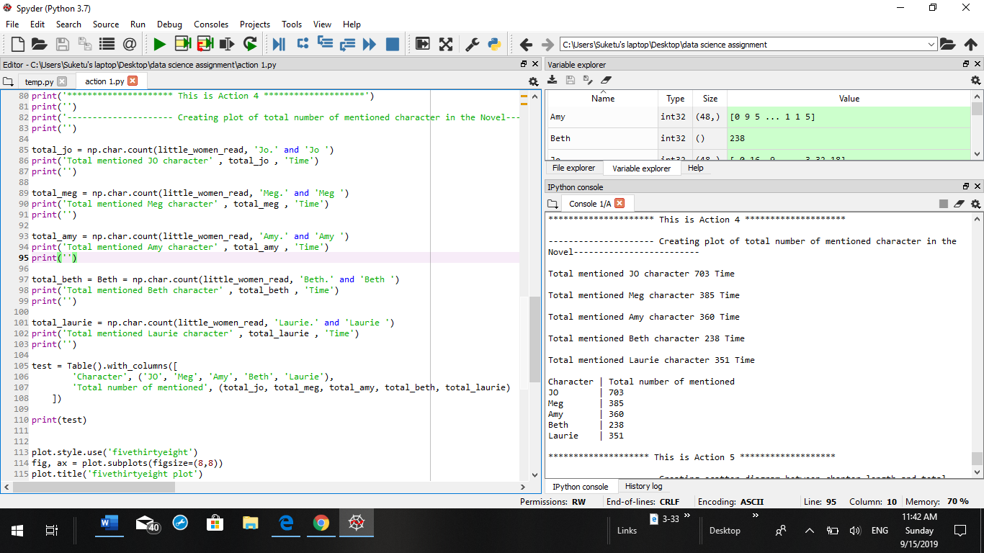

# Scatter daigram:

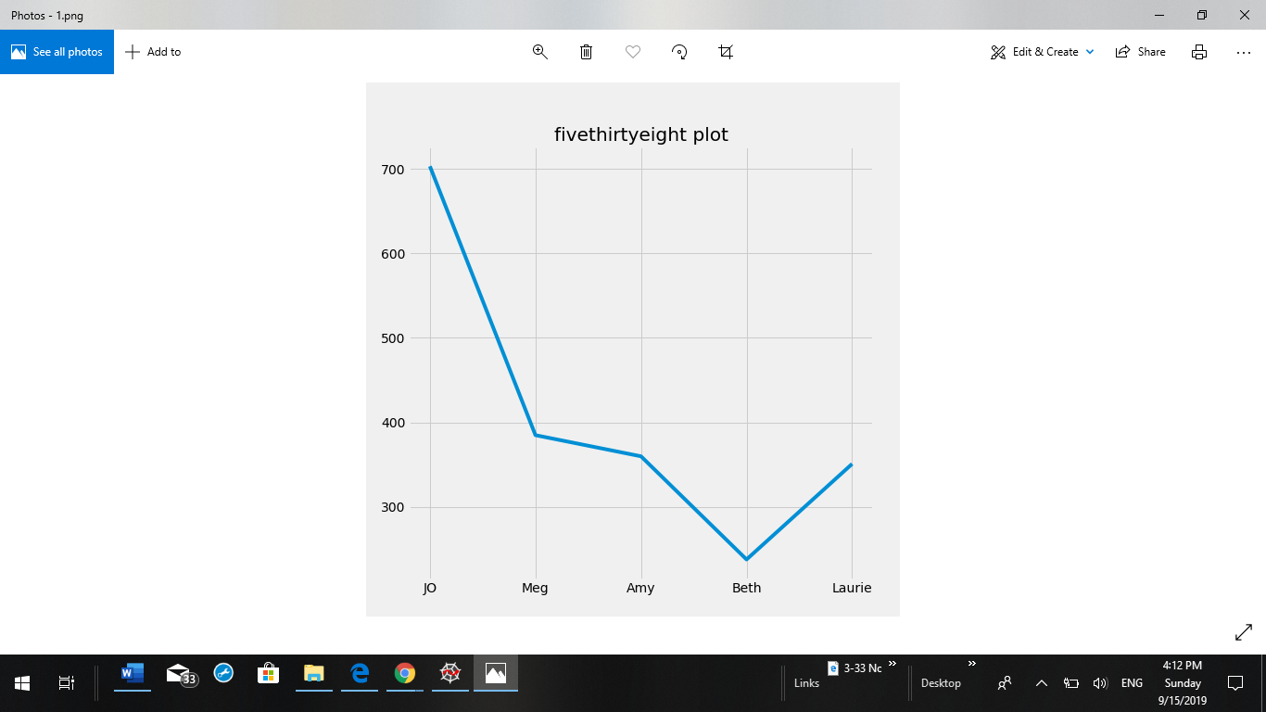

As observed from the scatter diagram it is articulates that the trend of the diagram is maximum when “Jo” character was mentioned in each chapters of novel. While trend took a straight downfall when “Meg” character was mentioned in the novel. While trend remain steady when “Amy” character was mentioned. When “Beth” character was mentioned in the chapter than trend fall maximum times compared to other four characters “Beth” was mentioned minimum time in the novel. Last but not the least When “Laurie” character mentioned in the chapter than it slightly increases to Amy’s level so However it is seen that “Jo” character is mentioned maximum time in all the chapters of novel.

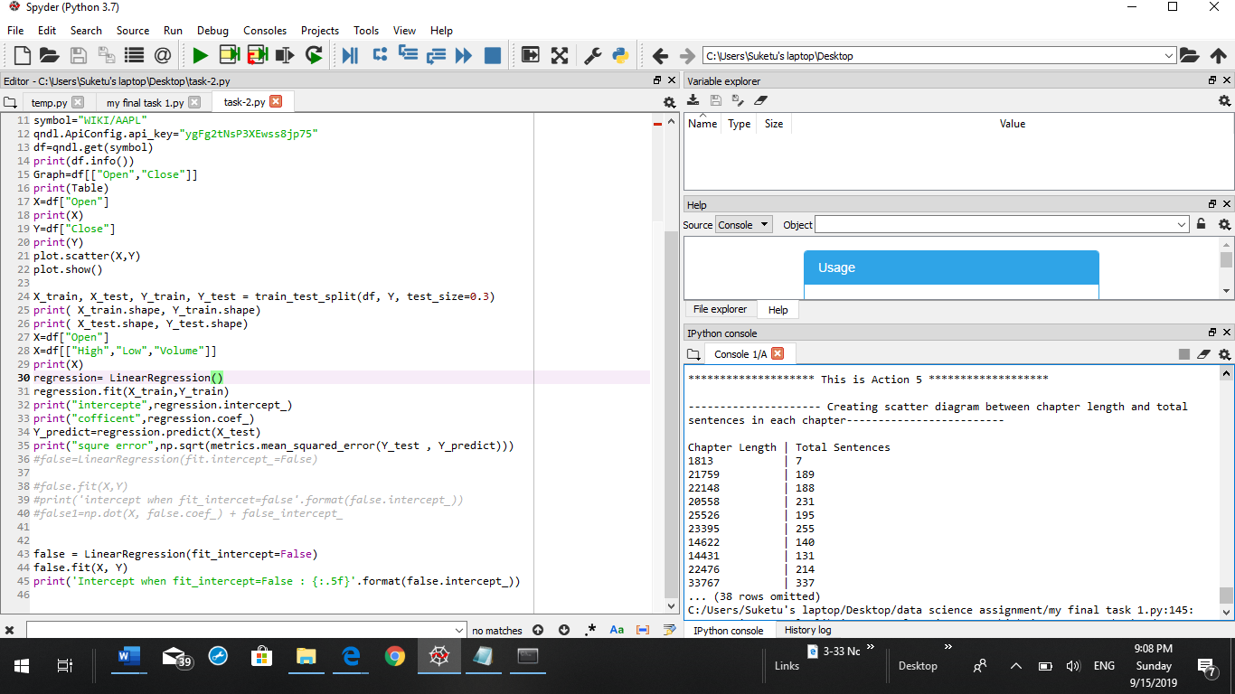

In this table it was observed that chapter length and total sentence in a sequence the maximum chapter length of the novel was 33767 and minimum number of length was 1813.In maximum number of sentence there were 337 sentences in maximum length of chapter and minimum number of sentence in whole table was 7 which eventually has minimum length of chapter in the novel

## Action-5:

Thus, In Action-1 it read text from the novel in Acyion-2 it was analyze that each character mentioned in a chapter for how many times .In Action-3 each and every text converted in to the table in a sequence so maximum character can be easily grab by the user. In Action-4 it was calculated that the total number of each character through chapter wise and total number of chapter and sentences are shown in the tables. By conducting this analysis I strongly believe that “Jo” is the main character in the novel.

# Task-2

## Action-1:

In action-1 user has to form different columns by amplifying an preliminary analysis of the data frame. User require to classify structures that can be used to foresee the variable for the explicit data that was of close columns

in-dependent variable=x

dependent variable=y

## Action-2:

In action-2 it determine the date and time index and calculation of total data column in the file

output:

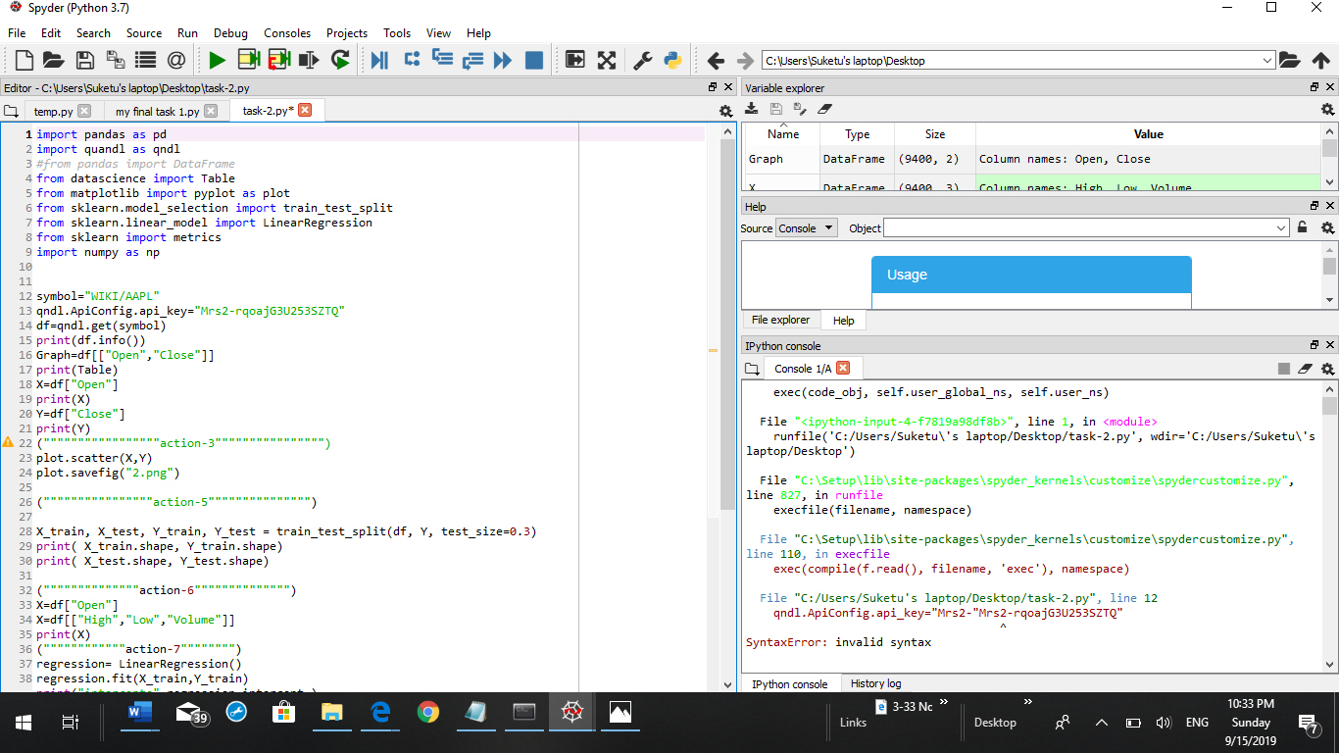

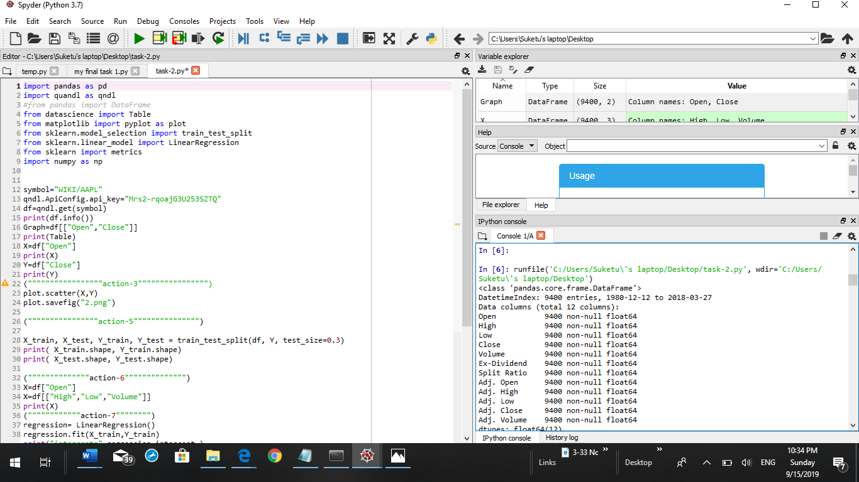

## Action-3:

In action-3 there was scatter plot daigram which represents the information regarding the dependent and in-dependent variable (x,y)

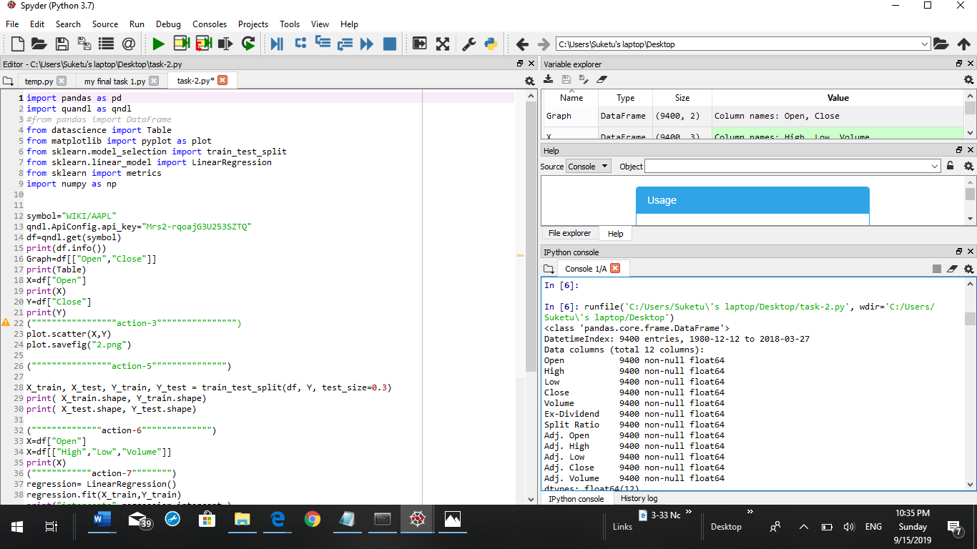

### output:

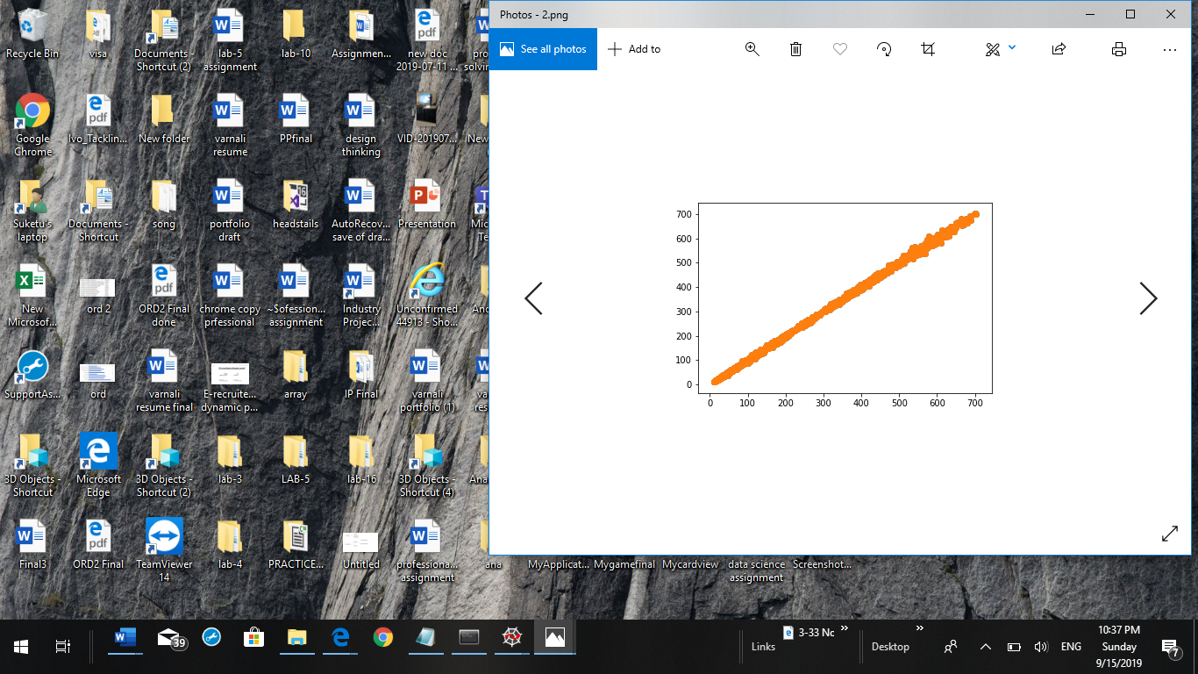

## Action-4:

positive corelation

## Action-5:

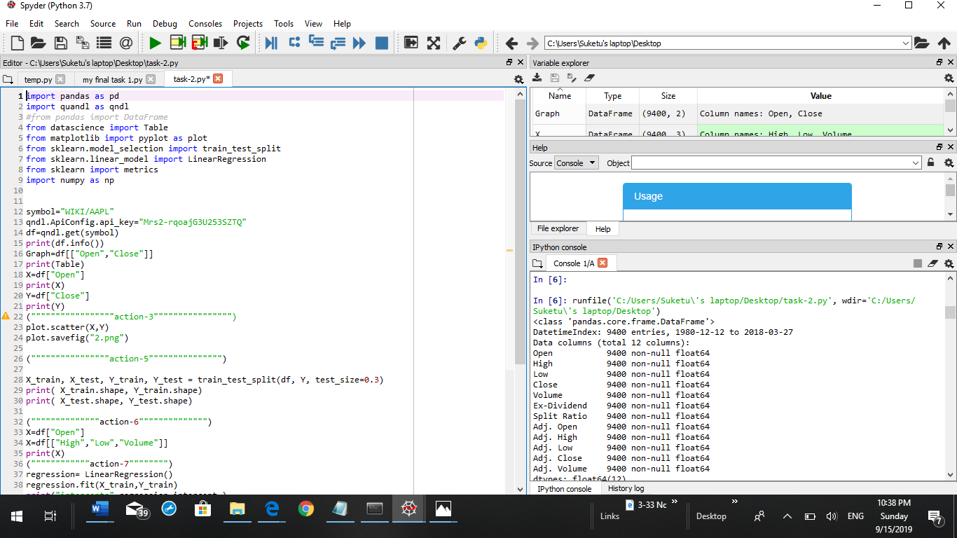

## Action-6:

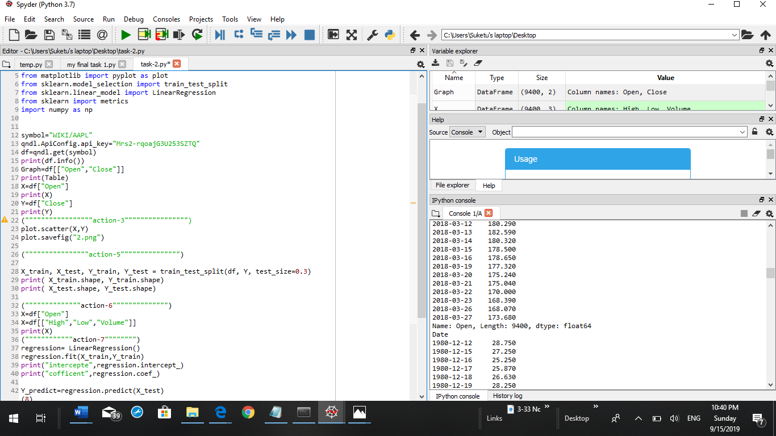

### Output:

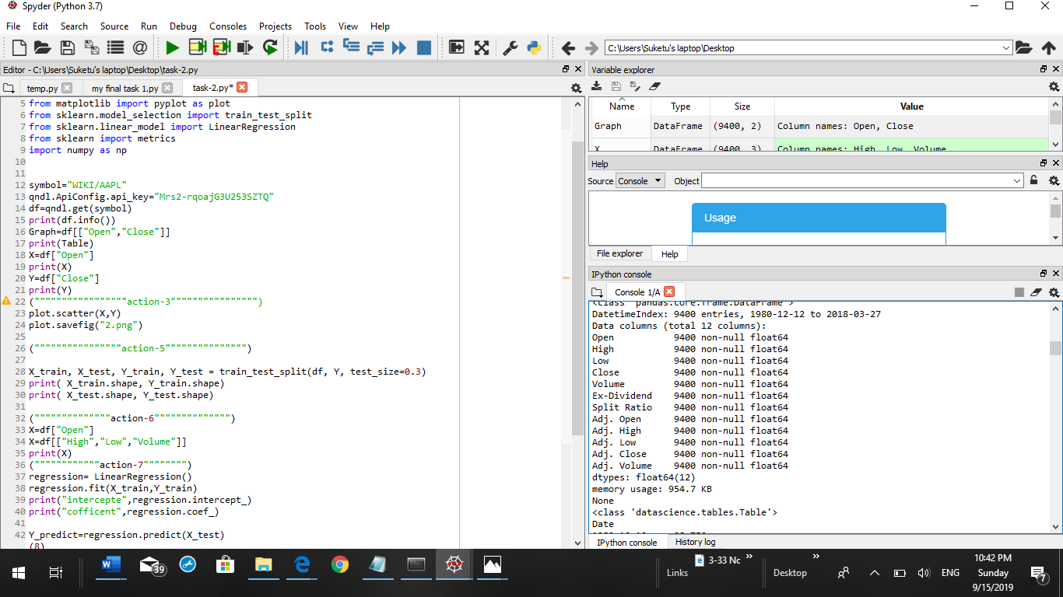

## Action-7:

In action 7 it shows the linear regression ,intercept and coefficient of x,y

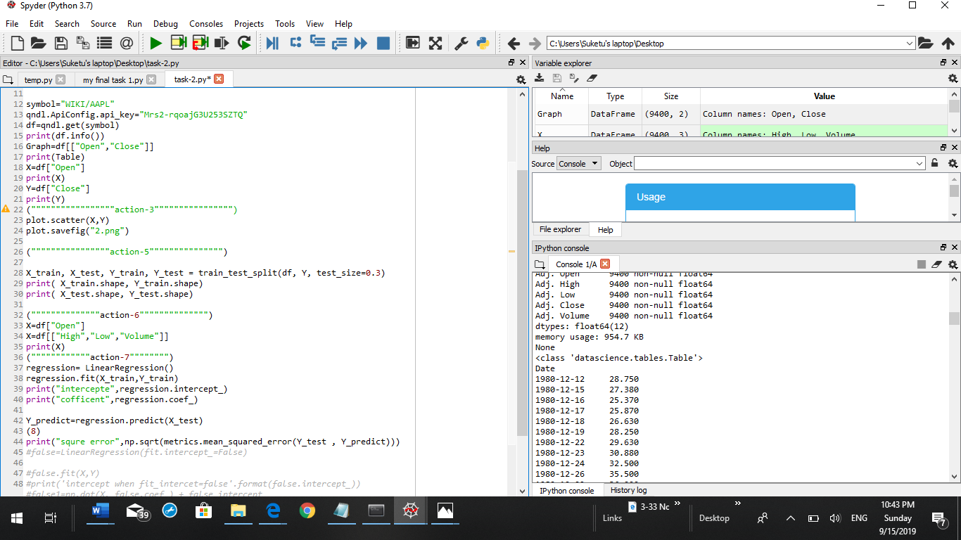

### output:

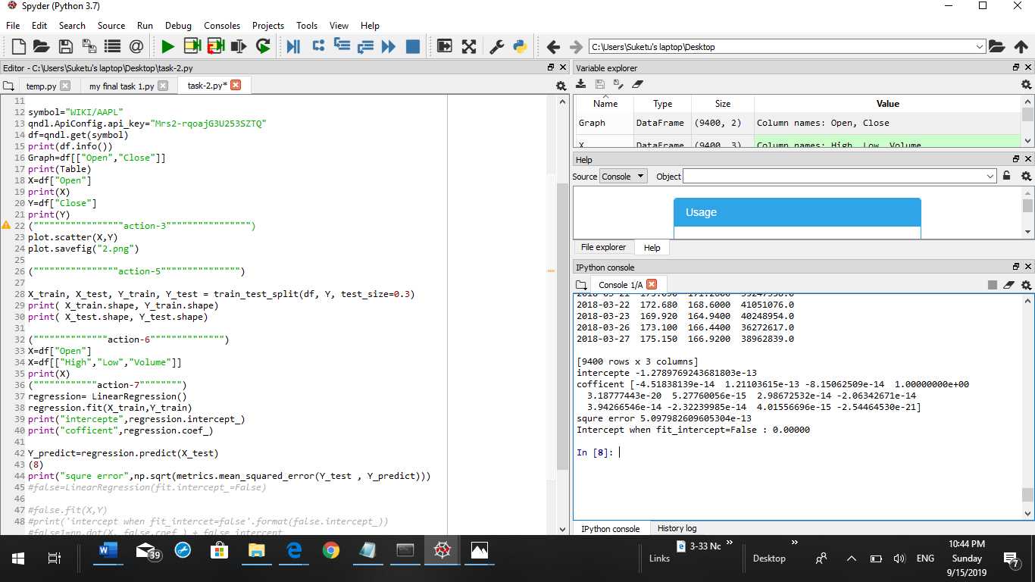

## Action-8:

In Action-8 it shows the square error of the variable

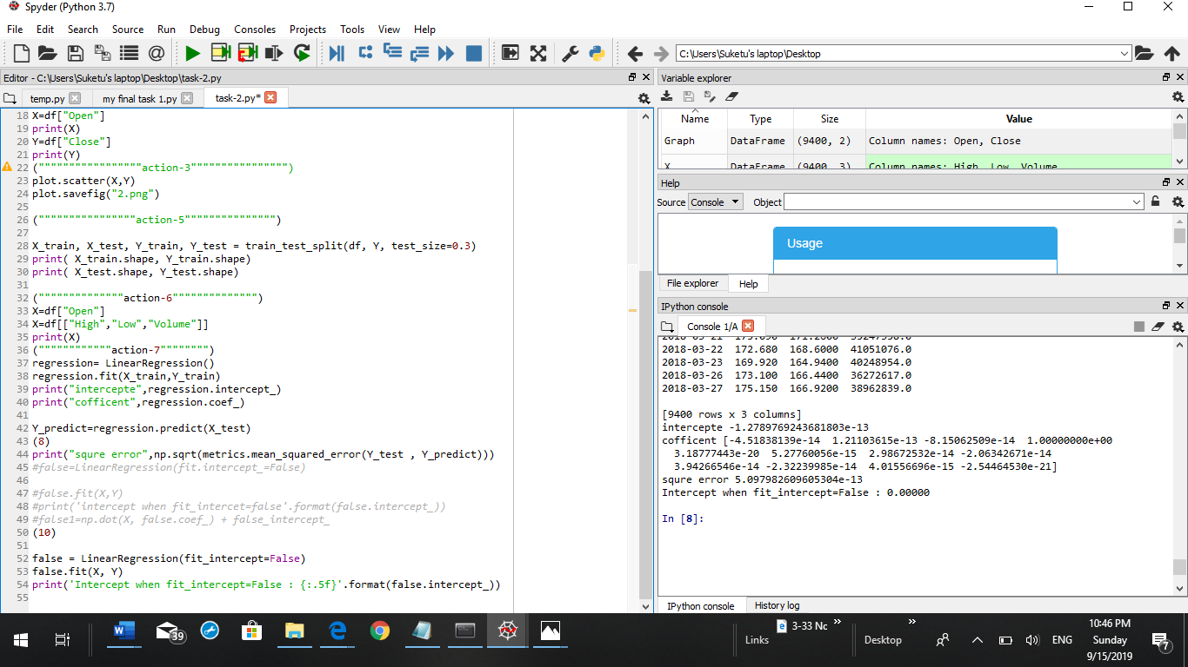

### output:

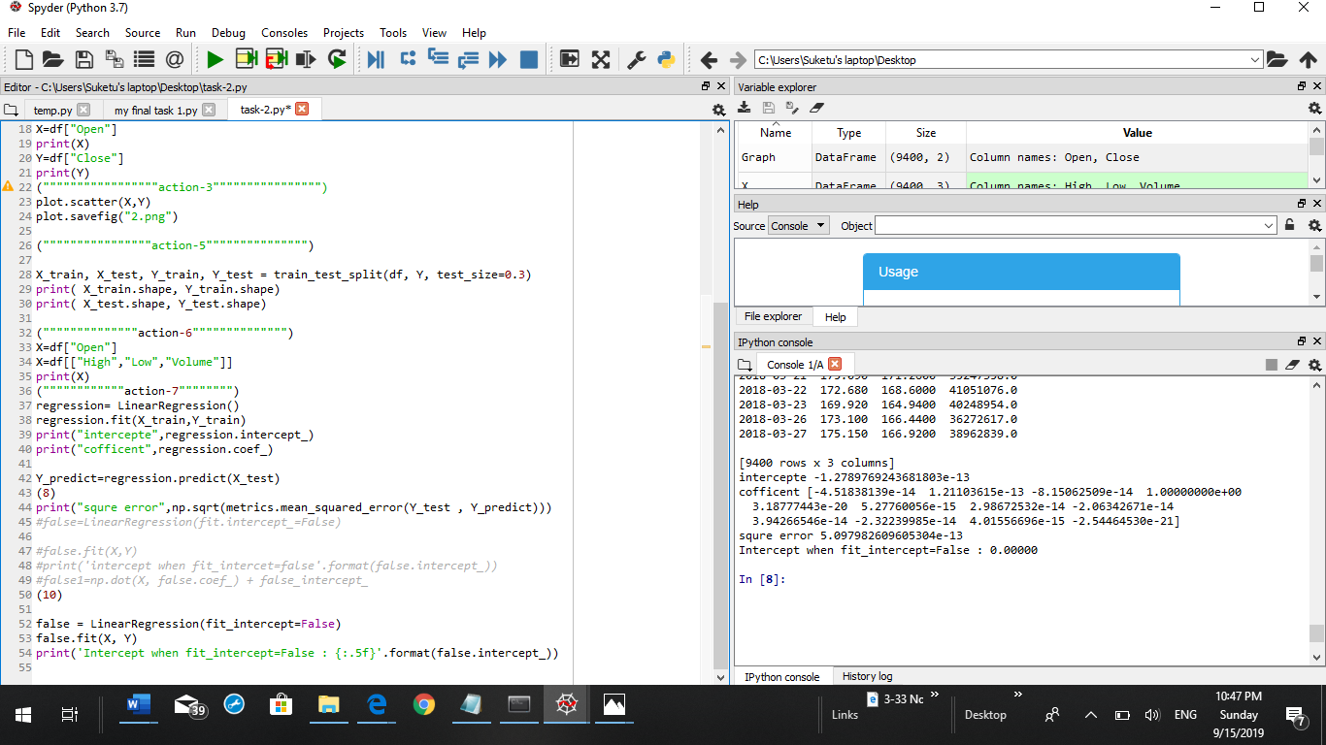

Action-10: 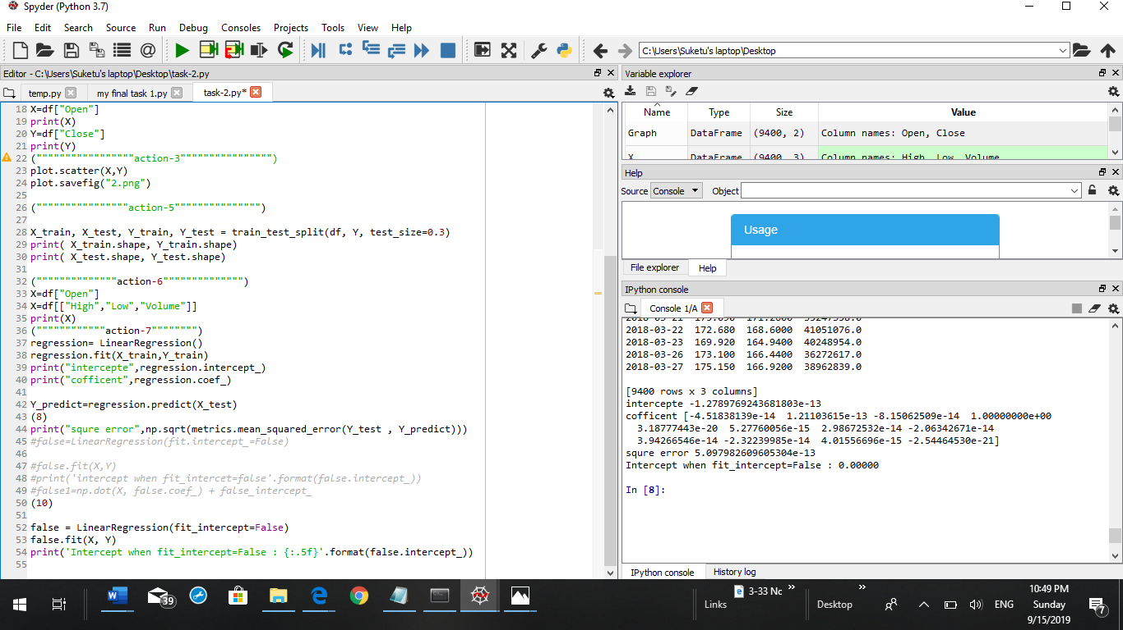

### output:

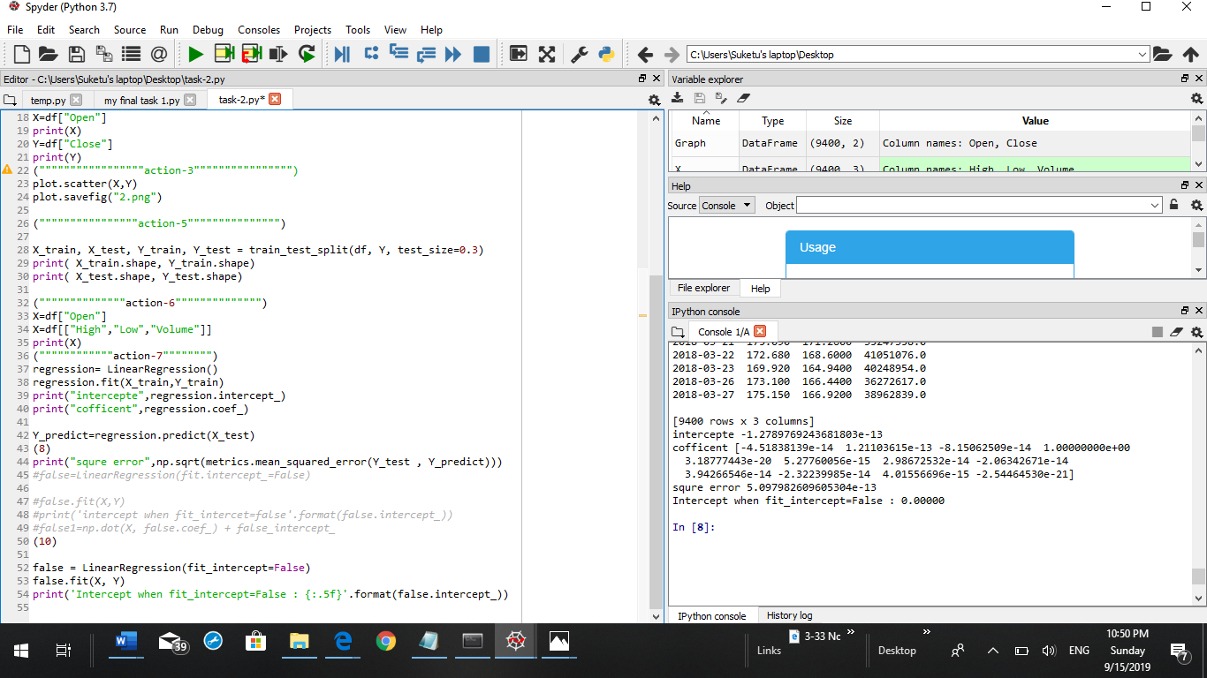

# Task-3

## Action-1:

In action-1 after observing the data set as per my observation there was sepal length ,sepal width,petal length,petal width,and variety is seen of different flower which is the data of flower with different components of flower.Which help to analyze the data easily

## Action-2

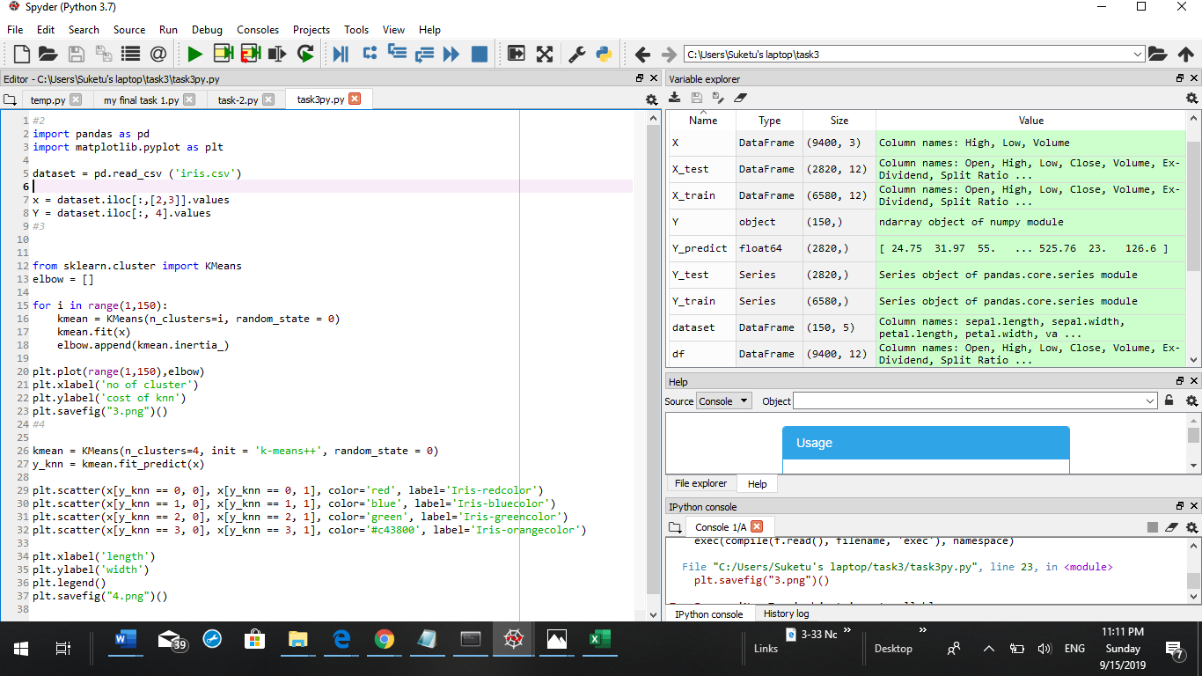

## Action-3

In action-3 it shows the number of cluster in the graph

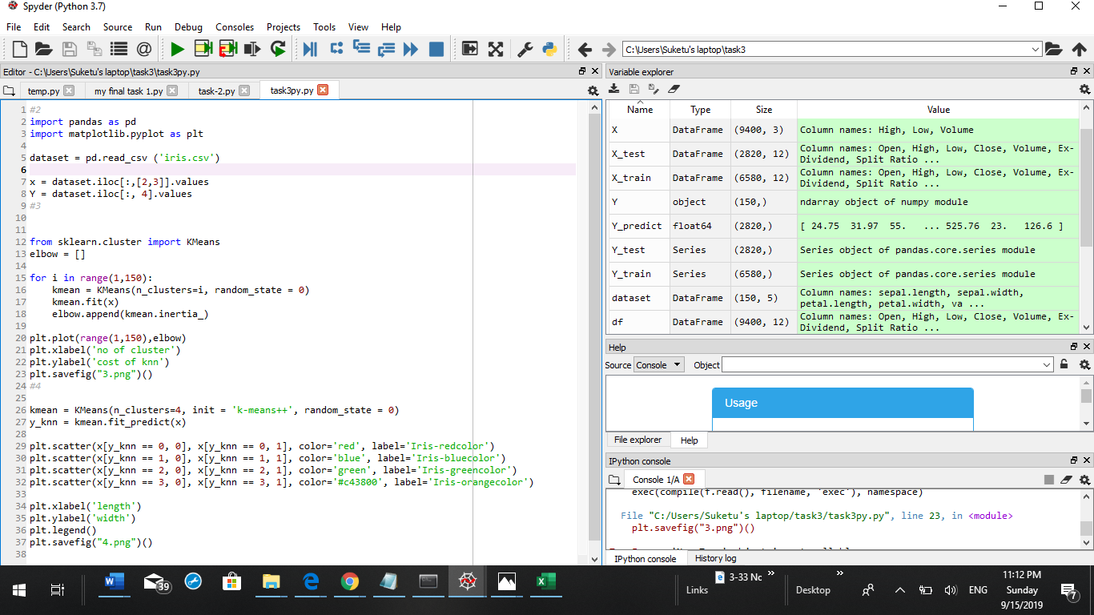

### output:

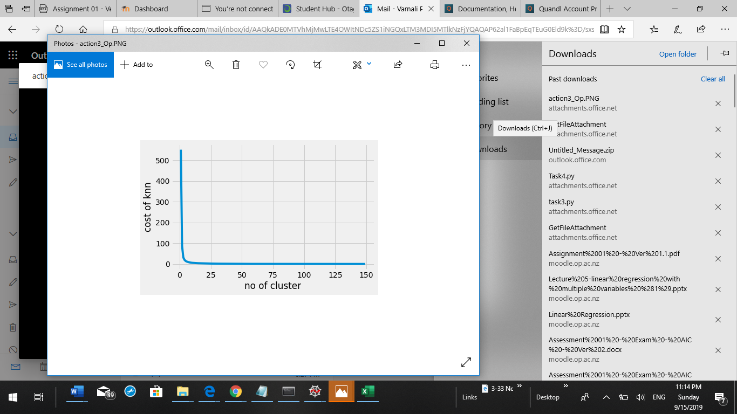

## Action-4:

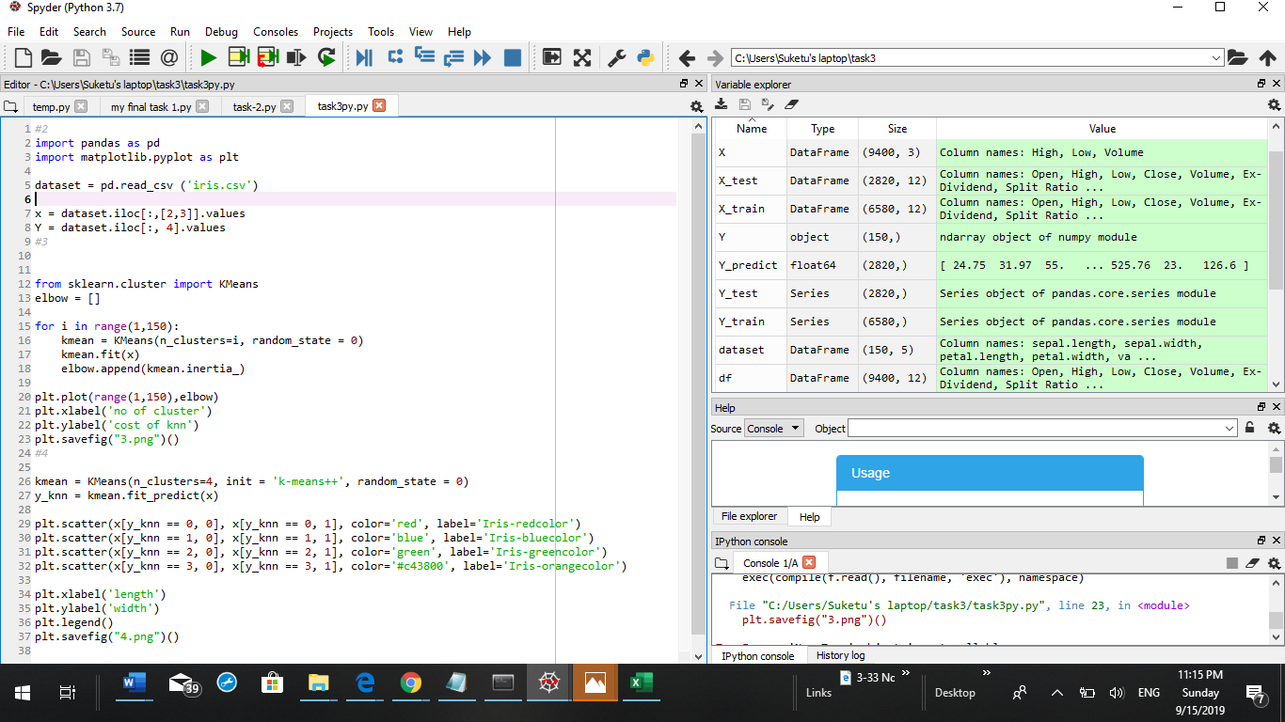

### output:

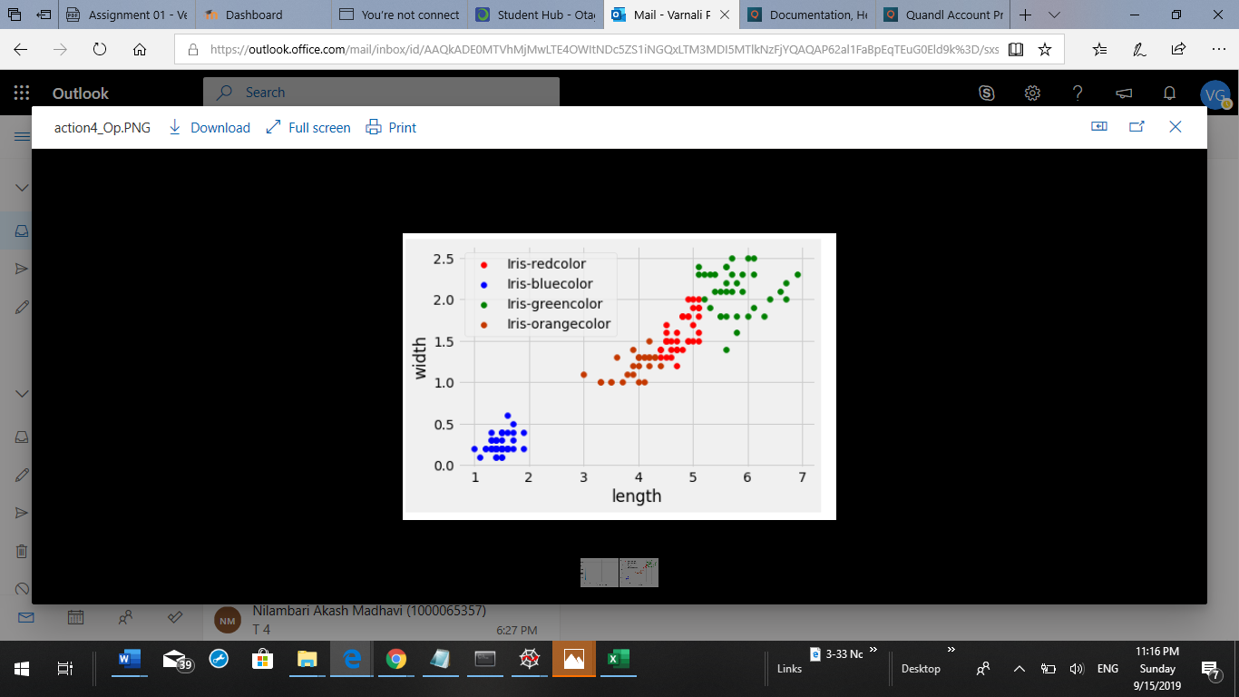

# Task-4:

## Action-1

## Action-2

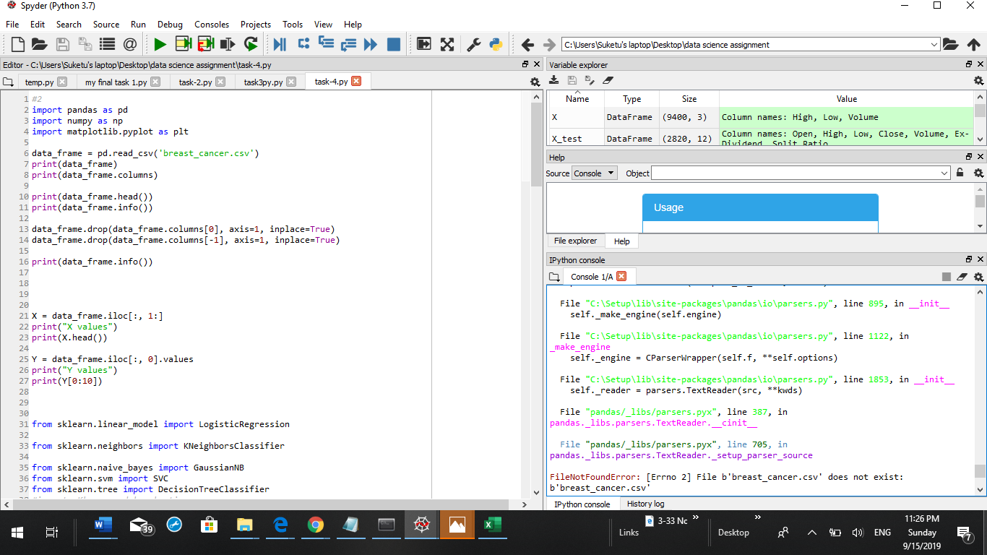

## Action-3

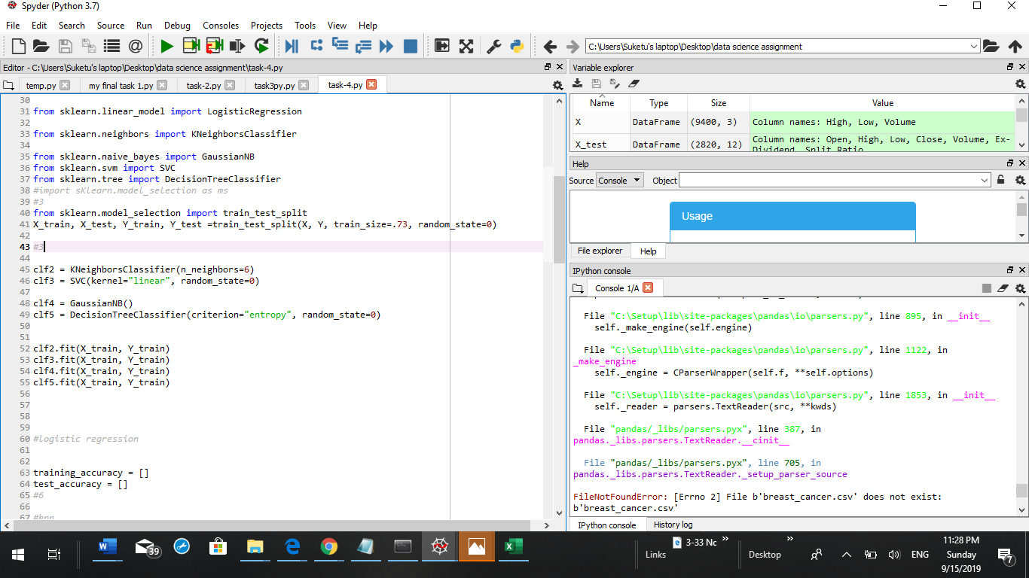

### output:

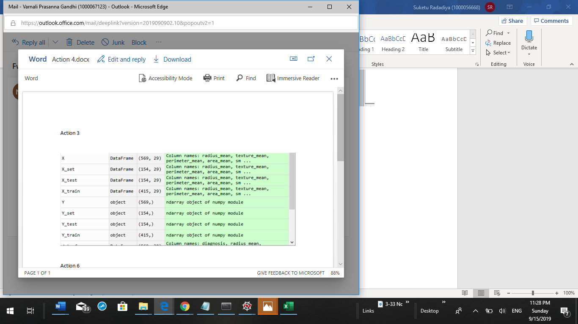

## Action:5

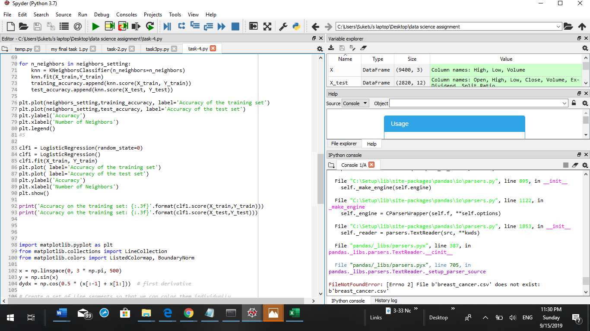

## Action-6:

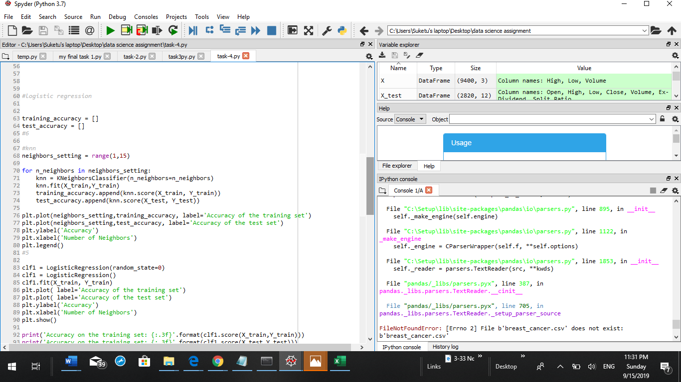

### output:

